Hot Tub Deck Trellis / Roof Structure
Construction Design & Material Takeoff
Project: R. Grant Stephens — Cabin Property, Menifee/Wolfe County, KY
Structure: Freestanding post-and-beam trellis / mono-slope roof over sunken hot tub deck
Date: July 22, 2026 Rev: A — Preliminary, for contractor pricing & material ordering
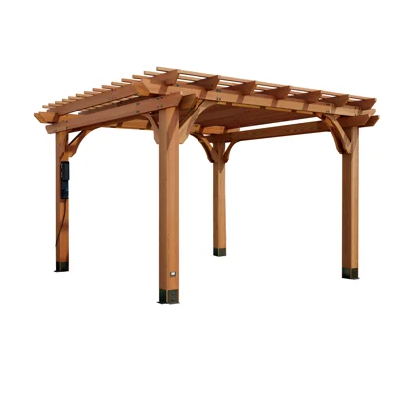
Figure 1 — Design reference: cedar-tone post-and-beam pergola with curved knee braces. This document adapts the look to a solid mono-slope roof (metal roofing over 1x6 decking and felt) sized for the hot tub deck footprint.

1. Design Basis & Assumptions
This document sizes a 4-post, perimeter-beam trellis/roof structure over the sunken hot-tub deck, styled after the reference photo above, but converted from an open-lattice pergola to a solid mono-slope ("shed") roof: metal panels over 15# felt over 1x6 roof decking, on 2x8 rafters, on a 6x8 perimeter beam ring, on 6x6 posts. All lumber is rough sawn (full/true dimension) per your specification.

1.1 Geometry
Parameter | Value
Footprint width (W) — along house/deck edge, post-to-post | 12'-0" (144")
Footprint depth (D) — house side to outer side, post-to-post | 9'-10 1/4" (118.25")
Post height — deck surface to top of high-side beam | 7'-6" (90")
Roof slope | 5% (≈ 2.9°), high side at house, low side outward
Roof overhang beyond beam ring, all 4 sides | 12"
Rafter spacing | 24" o.c. (7 rafters total across the 12'-0" width)
These dimensions match the deck footprint (12'-0" x 9'-10 1/4") and trellis parameters used in the earlier 3D site model for this project. Field-verify against the actual built deck before ordering material.

1.2 Assumed Design Loads
Load | Value | Basis
Ground snow load | 20 psf | Typical eastern KY value — verify against current ASCE 7 map for Menifee/Wolfe County
Roof snow load | ≈15 psf | 0.7 exposure/thermal factor on ground snow, rounded up
Dead load (framing + 1x6 deck + felt + metal) | ≈6 psf | Estimated from material weights
Combined design roof load (used for sizing below) | 30 psf | Conservative round number; provides extra margin beyond the ≈21 psf calculated demand
Wind was NOT explicitly calculated here. Converting the roof from an open lattice (as in the reference photo) to a solid metal panel roof substantially increases both lateral (racking) and uplift wind loads on a freestanding structure with no attachment to the house. Have a Kentucky-licensed PE check wind uplift and specify connection hardware before construction — see §4.

1.3 Lumber Design Values Assumed
Rough sawn, non-grade-stamped lumber from a local sawmill typically has no assigned allowable design values. The calculations below use conservative assumed values so that the design is safe even if the actual rough sawn stock is weaker than typical graded lumber of the same species:
- Posts & beams (6x6, 6x8 timber-size members): Fb = 750 psi, Fc (parallel to grain) = 600 psi, E = 1.2 x 10⁶ psi
- Rafters (2x8 dimension lumber): Fb = 1050 psi (SYP No.2 reference value), E = 1.4 x 10⁶ psi — but section properties conservatively computed using S4S actual dimensions (1.5" x 7.25") even though true rough sawn 2x8 stock will be closer to full 2" x 8", which would add further margin.
If the sawmill can provide a grade stamp or species/grade certification, an engineer can re-check these members against the higher published NDS values and potentially reduce sizes — but the sizes below are already modest and readily available, so it's rarely worth the trouble.

2. Structural Member Summary
Member sizes and the calculated demand/capacity for each, using the assumptions in §1:
Member | Size | Span / Trib. Width | Governing Check | Utilization
Rafters | 2x8 rough sawn @ 24" o.c. | 9'-10" span (+12" cantilevered tail) | Bending: 55% · Deflection: 39% (L/240) | Pass, 45%+ margin
Front/back beams (carry rafter ends) | 6x8 rough sawn | 12'-0" span, 30 psf x 6' trib. | Bending: 70% · Deflection: 46% (L/240) | Pass, ~30% margin
Side beams (perimeter tie, corner-to-corner) | 6x8 rough sawn | 9'-10 1/4" span, lightly loaded | Governed by connections/rigidity, not bending | Pass, large margin
Posts | 6x6 rough sawn, 90" unbraced height | ~38 sf tributary roof area / post | Axial: ~8% of allowable · slenderness ratio 16.4 (OK) | Pass, large margin — governed by lateral/uplift connections, not gravity load
"Utilization" is demand ÷ allowable capacity. All members check adequate with meaningful reserve capacity for the assumed 30 psf design roof load. Actual sawmill dimensions, species, and moisture content will shift these numbers slightly — the margins above are intended to absorb that variability, not to be consumed by it.

3. Framing Plan & Section
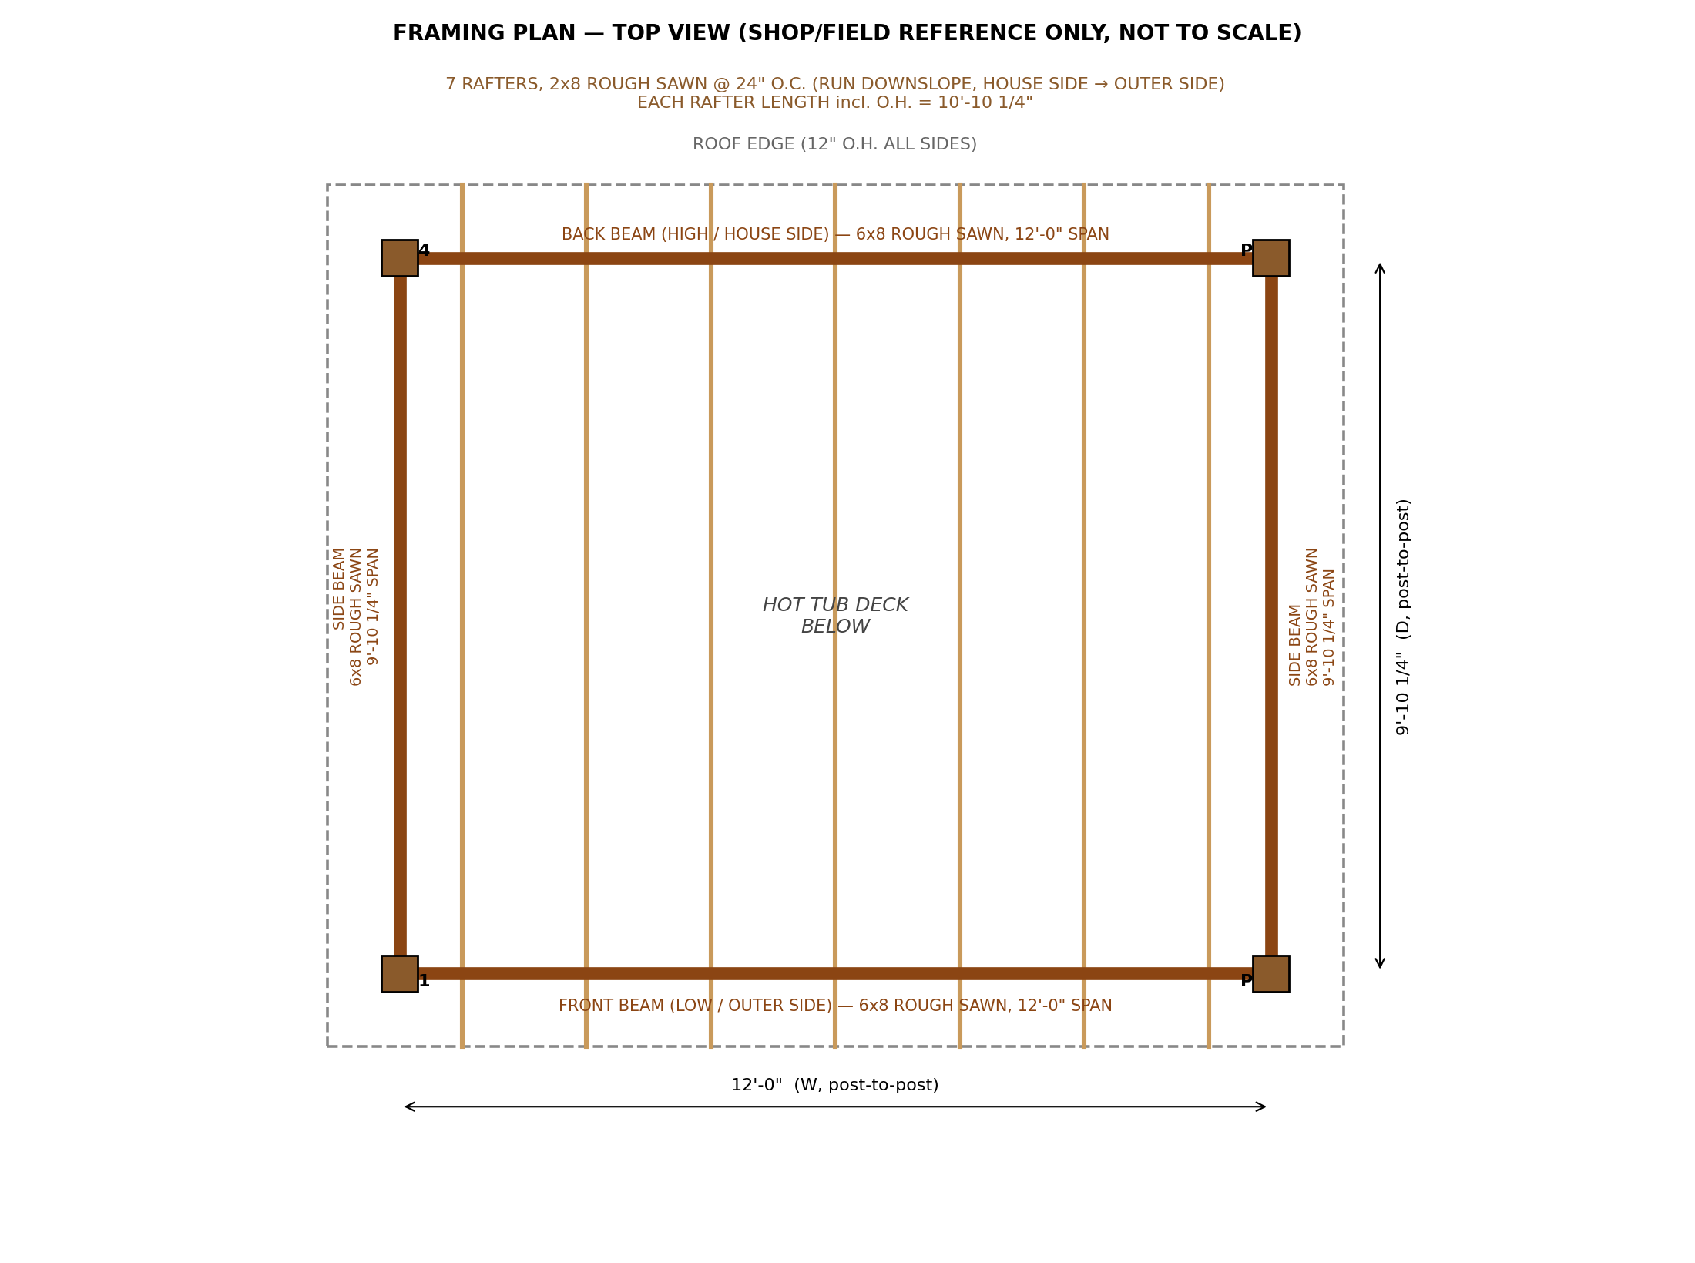
Figure 2 — Framing plan (top view). Posts (P1–P4) at the four corners; a 6x8 beam ring ties post tops together on all 4 sides; 7 rafters at 24" o.c. run in the slope direction (house side → outer side), overhanging the beam ring by 12" at all edges.
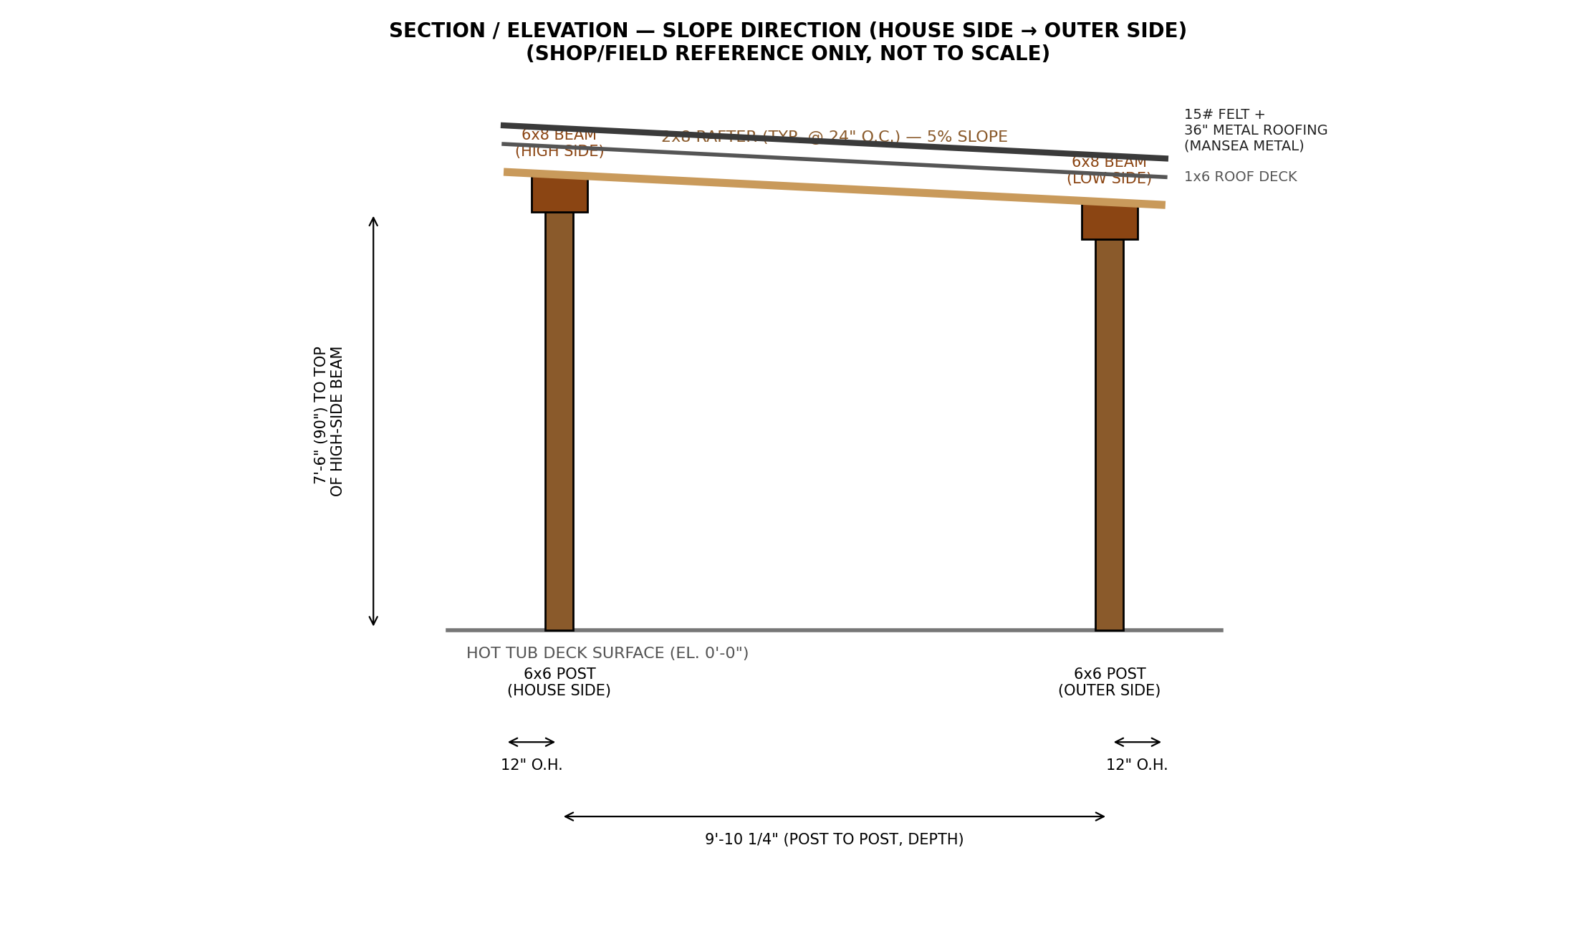
Figure 3 — Section/elevation through the slope direction, showing post height, 5% slope, roof assembly build-up, and the 12" overhangs at both ends.

4. Connections & Hardware
Connection | Recommended Hardware / Detail
Post base (4x) | Galvanized adjustable/standoff post base (e.g. Simpson ABU66 or equal) through-bolted to a concrete pier; keeps post end grain off wet concrete
Post-to-beam, each corner (4x) | Adjustable corner post cap rated for two intersecting 6x8 beams (e.g. Simpson ECCQ66SDS2.5 or equal), plus structural screws per manufacturer spec
Decorative knee braces (8x, 2 per post) | Curved 2x10 rough sawn (or 2-ply laminated 2x8) brace, through-bolted to post and beam — matches the reference photo's bracket detail; primarily aesthetic/stiffening, not a substitute for the post cap connection
Rafter-to-beam, each end (14x = 7 rafters x 2 ends) | Hurricane tie (Simpson H1 or H3, or equal) at every rafter bearing point — important once the roof is solid metal rather than open lattice, due to wind uplift
Roof deck-to-rafter | 1x6 boards fastened with (2) #8 x 2" deck screws (or 8d ring-shank nails) at every rafter crossing
Footings (4x) | 16" diameter concrete pier, min. 30" deep (verify local frost depth / karst conditions with contractor), embedded anchor bolt for post base bracket
Hardware sizes/models above are typical recommendations for members of this size; have your contractor or a PE confirm exact hardware selection and fastening schedule, especially the post cap and hurricane tie capacities against actual local wind speed.

5. Roofing Assembly
From the rafters up: 1x6 rough sawn roof decking, 15# felt underlayment, 36"-wide metal roofing panels (Mansea Metal, Winchester, KY).
- Roof deck: 1x6 rough sawn boards run perpendicular to the rafters (parallel to the beams), laid tight edge-to-edge (tongue-and-groove preferred for a smoother, more weathertight substrate). Fasten per §4 above.
- Underlayment: 15# felt, applied horizontally in courses starting at the low (outer) eave, minimum 2" side laps and 4" head laps, stapled per standard practice. Since the roof is a simple mono-slope with no valleys, standard coursing is sufficient.
- Metal roofing: 36" nominal coverage width panels from Mansea Metal, run down-slope (parallel to the rafters), custom-cut to length in the field or ordered pre-cut. Confirm exact net coverage width for the specific profile ordered (some profiles net slightly less than 36" after seam overlap) before finalizing the panel layout below.
- Eaves & rakes: install drip edge at the low (outer) eave; a simple hemmed panel edge or small cap trim at the high (house-side) eave since there is no wall to flash into; rake trim along both ends of the slope. A gutter at the low eave is optional and not included in the takeoff below.
- Fasteners: manufacturer-recommended stainless or galvanized structural screws with EPDM/neoprene washers, spaced per Mansea Metal's installation instructions for the panel profile ordered (typically 12"–24" o.c. along the panel ribs into the 1x6 decking).
Contact Mansea Metal (Winchester, KY) directly for the panel profile catalog, exact net coverage width, and current fastener/closure-strip recommendations before finalizing the order — this takeoff assumes a generic 36" exposed-fastener or standing-seam profile.

6. Material Takeoff

6.1 Framing Lumber (rough sawn)
Item | Size | Length | Qty | Board Ft. (approx.)
Posts | 6x6 | 8'-0" (trim to 90" finished) | 4 | 96
Front/back beams | 6x8 | 12'-0" | 2 | 96
Side beams | 6x8 | 10'-0" (trim to 118 1/4") | 2 | 80
Rafters | 2x8 | 12'-0" (trim to length + decorative tail) | 7 | 112
Roof decking | 1x6 | 14'-0" (or 2 pcs 7'-0" per row, joint over a rafter) | 24 | 168
Decorative knee braces | 2x10 (cut to curved profile) | 3'-0" blank | 8 | 40
Subtotal: ≈592 board ft. Order ≈650 board ft. (+10% waste/cutting allowance).

6.2 Roofing & Underlayment
Item | Spec | Qty
Metal roofing panels | Mansea Metal, 36" nominal coverage width, ~11'-0" length (verify exact profile/coverage before ordering) | 5 panels (2 field-trimmed for width close-out)
Underlayment | 15# roofing felt, 36" x 144' roll (432 sf) | 1 roll
Panel fasteners | Structural screws w/ EPDM washer, per Mansea spec | ≈250 pcs (verify spacing with install guide)
Eave drip edge (low side) | Standard metal drip edge | 14 lf
High-side eave/hem trim | Per Mansea profile | 14 lf
Rake trim (both ends) | Per Mansea profile | 22 lf
Closure strips (both eaves) | Foam or vented, per panel profile | 28 lf
Sealant / butyl tape | For laps & fastener sealing | 2–3 tubes/rolls

6.3 Hardware & Connectors
Item | Qty
Adjustable/standoff post base (Simpson ABU66 or equal) | 4
Adjustable corner post cap for 6x8 beams (Simpson ECCQ66SDS2.5 or equal) | 4
Hurricane tie, rafter-to-beam (Simpson H1/H3 or equal) | 14
Structural wood screws (6"–8", e.g. GRK RSS or Simpson SDWS) | ≈48 (verify per hardware mfr. schedule)
Deck screws (#8 x 2") for 1x6 roof decking | ≈340 (24 boards x ~14 crossings avg.)
Galvanized carriage bolts / through-bolts (knee braces) | 16 (2 per brace)

6.4 Concrete / Footings
Item | Spec | Qty
Sonotube concrete piers | 16" diameter x 30" deep (verify local frost depth) | 4
Concrete | ≈3.5 cf per pier, ≈14 cf total | ≈0.55 cu yd, or ≈22 bags 80 lb premix
Post anchor bolts | Per post base bracket spec, embedded in wet concrete | 4

7. Construction Sequence (Summary)
- Layout & footings
  - Square and layout the 4 post locations from the deck; verify against as-built deck dimensions.
  - Dig/form and pour the 4 concrete piers with embedded anchor bolts; let cure before loading.
- Posts & beam ring
  - Set post bases, plumb and brace the 4 posts at 90" (7'-6") to top of high-side beam bearing.
  - Set the two 6x8 front/back beams and two 6x8 side beams to form the perimeter ring; fasten with corner post caps.
  - Install the 8 decorative curved knee braces.
- Rafters & roof deck
  - Set 7 rafters at 24" o.c. on the front/back beams, 5% slope, 12" overhang at both ends; fasten with hurricane ties.
  - Install 1x6 roof decking across the rafters, tight-fit, 12" overhang at both sides.
- Roofing
  - Install 15# felt underlayment starting at the low eave.
  - Install eave drip edge, rake trim, and closure strips.
  - Install Mansea Metal panels down-slope per manufacturer instructions.

8. Disclaimer
This document is a preliminary design intended to support contractor pricing, material ordering, and construction layout. It is NOT a stamped engineering document. Have a Kentucky-licensed structural engineer review and stamp final drawings before construction — in particular the wind/uplift design and connection hardware (given the freestanding structure and solid metal roof), footing design for local soil/karst conditions, and current code-required snow and wind loads for Menifee/Wolfe County. Field-verify all dimensions against the as-built deck before ordering material.

